МИНИСТЕРСТВО ТРАНСПОРТА РОССИЙСКОЙ ФЕДЕРАЦИИ

ФЕДЕРАЛЬНОЕ АГЕНТСТВО ЖЕЛЕЗНОДОРОЖНОГО ТРАНСПОРТА

Государственное бюджетное образовательное учреждение

высшего образования

«ПЕТЕРБУРГСКИЙ ГОСУДАРСТВЕННЫЙ УНИВЕРСИТЕТ

ПУТЕЙ СООБЩЕНИЯ ИМПЕРАТОРА АЛЕКСАНДРА I»

Кафедра «ИНФОРМАЦИОННЫЕ И ВЫЧИСЛИТЕЛЬНЫЕ СИСТЕМЫ»

Дисциплина: «Программирование(C)»

ОТЧЕТ

по лабораторной работе № 6

Вариант *19*

Выполнил студент Шефнер А.

Факультета *АИТ*

Группы *ИВБ-211*

Санкт-Петербург

2023

**Постановка задачи**

1) Создать односвязный список. Данными списка должны быть структуры из задания № 4 соответствующего варианта. Создать функции для записи списка в файл и чтения списка из файла.

2) Реализовать минимум все функции, приведённые в лекции, предложить предложить свои варианты функций работы со списком.

3) Создать меню для управления работы со списком.

**Пояснения**

Мой список является отдельной структурой list, в которой находится количество элементов, ссылка на голову и ссылка на хвост листа. Данные хранятся в узлаъ node в виде указателей на void. Это позволяет Вам использовать данный список не только со структурой book, но и вообще с любыми другими структурами, если Вы работаете с ними через указатели. Для очистки списка сначала примените процедуру free для каждого элемента (это может сделать моя функция list_apply), а зачем вызовате list_delete.

**Код программы**

**c_lab_6.c** (точка входа программы и меню взаимодействия со списком)

**#define _CRT_SECURE_NO_WARNINGS**

**#include <stdio.h>**

**#include <stdlib.h>**

**#include "book.h"**

**#include "list.h"**

**#include "booksfile.h"**

**#define ACTION_COUNT 14**

**list* book_list;**

**void(*actions[ACTION_COUNT])(void);**

**char* action_names[ACTION_COUNT];**

**void action_get_head(void);**

**void action_list_get_tail(void);**

**void action_list_get(void);**

**void action_get_from_end(void);**

**void action_show_list(void);**

**void action_push_back(void);**

**void action_push_front(void);**

**void action_insert(void);**

**void action_pop_back(void);**

**void action_pop_front(void);**

**void action_remove_at(void);**

**void action_remove_from_end(void);**

**void action_load_from_file(void);**

**void action_write_to_file(void);**

***// void** list_to_array(const list* list);***

**void init_actions(void);**

**void print_actions(void);**

**int main(int argc, char* argv[])**

**{**

**system("cls");**

**init_actions();**

**book_list = list_create();**

**printf("Welcome to the book management tool!\n");**

**while (1)**

**{**

**system("pause");**

**system("cls");**

**print_actions();**

**int action_num;**

**printf("Enter action number: ");**

**scanf("%d", &action_num);**

**if(action_num == 0) break;**

**if(action_num < 1 || action_num > ACTION_COUNT)**

**{**

**printf("Invalid action number.\n");**

**continue;**

**}**

**system("cls");**

**fseek(stdin,0,SEEK_END);**

**actions[action_num - 1]();**

**}**

**list_apply(book_list, free);**

**list_delete(book_list);**

**system("pause");**

**return 0;**

**}**

**void action_get_head(void)**

**{**

**printf("Head of the list:\n\n");**

**book_print(list_get_head(book_list));**

**}**

**void action_list_get_tail(void)**

**{**

**printf("Tail of the list:\n\n");**

**book_print(list_get_tail(book_list));**

**}**

**void action_list_get(void)**

**{**

**size_t index;**

**printf("Enter desired index: ");**

**scanf("%lld", &index);**

**book* book = list_get(book_list, index);**

**if(book == NULL)**

**{**

**printf("Invalid index.\n");**

**return;**

**}**

**printf("Book at index %lld in the list:\n\n", index);**

**book_print(book);**

**}**

**void action_get_from_end(void)**

**{**

**size_t index;**

**printf("Enter desired index: ");**

**scanf("%lld", &index);**

**book* book = list_get_from_end(book_list, index);**

**if(book == NULL)**

**{**

**printf("Invalid index.\n");**

**return;**

**}**

**printf("Book at index %lld in the list:\n\n", index);**

**book_print(book);**

**}**

**void action_show_list(void)**

**{**

**if(book_list->count == 0)**

**{**

**printf("The list is empty.\n");**

**return;**

**}**

**printf("List of the books:\n\n");**

**list_apply(book_list, book_print);**

**printf("\n\n");**

**}**

**void action_push_back(void)**

**{**

**printf(" Enter book:\n");**

**book* new_book = book_get_scanf();**

**list_push_back(book_list, new_book);**

**printf("\nBook added to list successfully.\n\n");**

**}**

**void action_push_front(void)**

**{**

**printf(" Enter book:\n");**

**book* new_book = book_get_scanf();**

**list_push_front(book_list, new_book);**

**printf("\nBook added to list successfully.\n\n");**

**}**

**void action_insert(void)**

**{**

**size_t index;**

**printf("Enter index (0 - %lld): ", book_list->count);**

**scanf("%lld", &index);**

**if(index < 0 || index >= book_list->count)**

**{**

**printf("Invalid index.\n");**

**}**

**printf(" Enter book:\n");**

**book* new_book = book_get_scanf();**

**list_insert(book_list, new_book, index);**

**printf("\nBook added to list successfully.\n\n");**

**}**

**void action_pop_back(void)**

**{**

**book* removed_book = list_pop_back(book_list);**

**if(removed_book == NULL)**

**{**

**printf("The list is empty.\n");**

**return;**

**}**

**printf("The book, popped out from back:\n\n");**

**book_print(removed_book);**

**free(removed_book);**

**}**

**void action_pop_front(void)**

**{**

**book* removed_book = list_pop_front(book_list);**

**if(removed_book == NULL)**

**{**

**printf("The list is empty.\n");**

**return;**

**}**

**printf("The book, popped out from front:\n\n");**

**book_print(removed_book);**

**free(removed_book);**

**}**

**void action_remove_at(void)**

**{**

**size_t index;**

**printf("Enter index (0 - %lld): ", book_list->count);**

**scanf("%lld", &index);**

**if(index < 0 || index >= book_list->count)**

**{**

**printf("Invalid index.\n");**

**}**

**book* removed_book = list_get(book_list, index);**

**list_remove_at(book_list, index);**

**printf("\nThe book, removed from the list:\n\n");**

**book_print(removed_book);**

**free(removed_book);**

**}**

**void action_remove_from_end(void)**

**{**

**size_t index;**

**printf("Enter index (0 - %lld): ", book_list->count);**

**scanf("%lld", &index);**

**if(index < 0 || index >= book_list->count)**

**{**

**printf("Invalid index.\n");**

**}**

**book* removed_book = list_get(book_list, index);**

**list_remove_at_from_end(book_list, index);**

**printf("\nThe book, removed from the list:\n\n");**

**book_print(removed_book);**

**free(removed_book);**

**}**

**void action_load_from_file(void)**

**{**

**char filename[100];**

**printf("Enter file name: ");**

**scanf("%s", filename);**

**list* tmp_list = get_book_list_from_file(filename);**

**if(tmp_list == NULL)**

**{**

**printf("Invalid file name.\n");**

**return;**

**}**

**list_apply(book_list, free);**

**free(book_list);**

**book_list = tmp_list;**

**printf("Books loaded successfully\n");**

**}**

**void action_write_to_file(void)**

**{**

**char filename[100];**

**printf("Enter file name: ");**

**scanf("%s", filename);**

**if(write_book_list_to_file(filename, book_list))**

**{**

**printf("Data successfully written to the file.\n");**

**}**

**else**

**{**

**printf("Error during writing the list to file.\n");**

**}**

**}**

**void init_actions(void)**

**{**

**actions[0] = action_get_head;**

**action_names[0] = "Get head of the list.";**

**actions[1] = action_list_get_tail;**

**action_names[1] = "Get tail of the list.";**

**actions[2] = action_list_get;**

**action_names[2] = "Get an element of the list at desired index.";**

**actions[3] = action_get_from_end;**

**action_names[3] = "Get an element of the list at desired index starting from the end.";**

**actions[4] = action_show_list;**

**action_names[4] = "Print all elements of the list.";**

**actions[5] = action_push_back;**

**action_names[5] = "Push back anew element to the list.";**

**actions[6] = action_push_front;**

**action_names[6] = "Push front anew element to the list.";**

**actions[7] = action_insert;**

**action_names[7] = "Insert a new elenebt in the list at the desired index.";**

**actions[8] = action_pop_back;**

**action_names[8] = "Pop back an element from the list and show it.";**

**actions[9] = action_pop_front;**

**action_names[9] = "Pop front an element from the list and show it.";**

**actions[10] = action_remove_at;**

**action_names[10] = "Remove an element from the list at the desired index.";**

**actions[11] = action_remove_from_end;**

**action_names[11] = "Remove an element from the list at the desired index starting from the end.";**

**actions[12] = action_load_from_file;**

**action_names[12] = "Load books from the file.";**

**actions[13] = action_write_to_file;**

**action_names[13] = "Write books to the file.";**

**}**

**void print_actions(void)**

**{**

**for(int i = 0; i < ACTION_COUNT; i++)**

**{**

**printf("%d - %s\n", i + 1, action_names[i]);**

**}**

**printf("\n%d - Exit.\n\n", 0);**

**}**

**book.h** (струтура книги и основные функции)

**#pragma once**

**#define SURNAME_CHAR_NUMBER 20**

**#define THEME_CHAR_NUMBER 50**

**#define FULL_CHAR_NUMBER 83**

**#define SURNAME_FORMAT "%20s"**

**#define THEME_FORMAT "%50s"**

**#define YEAR_FORMAT "%5hu"**

**#define PAGE_FORMAT "%5hu"**

**#define BOOK_FORMAT SURNAME_FORMAT" "THEME_FORMAT" "YEAR_FORMAT" "PAGE_FORMAT**

**typedef struct book**

**{**

**char surname[SURNAME_CHAR_NUMBER + 1];**

**char theme[THEME_CHAR_NUMBER + 1];**

**unsigned short year;**

**unsigned short page_count;**

**} book;**

**void book_print(book* book);**

**book* book_get_scanf(void);**

**book.с**

**#define _CRT_SECURE_NO_WARNINGS**

**#include "book.h"**

**#include <stdio.h>**

**#include <stdlib.h>**

**#include <string.h>**

**void write_str_without_trailing_spaces(char* str_ptr)**

**{**

**while (*str_ptr == ' ') str_ptr++;**

**while (*str_ptr != '\0')**

**{**

**char tmp = *str_ptr == '_' ? ' ' : (char)(*str_ptr);**

**putc(tmp, stdout);**

**str_ptr++;**

**}**

**}**

**void book_print(book* book)**

**{**

**write_str_without_trailing_spaces(book->surname);**

**printf(" - ");**

**write_str_without_trailing_spaces(book->theme);**

**printf("\nyear: %d. %d pages.\n\n", book->year, book->page_count);**

**}**

**book* book_get_scanf(void)**

**{**

**fseek(stdin,0,SEEK_END);**

**book* book = malloc(sizeof(struct book));**

**printf("\nEnter surname:\n");**

**fgets(book->surname, SURNAME_CHAR_NUMBER, stdin);**

**book->surname[strcspn(book->surname, "\r\n")] = '\0';**

**printf("Enter theme:\n");**

**fgets(book->theme, THEME_CHAR_NUMBER, stdin);**

**book->theme[strcspn(book->theme, "\r\n")] = '\0';**

**printf("Enter year: ");**

**scanf("%hd", &book->year);**

**printf("Enter page count: ");**

**scanf("%hd", &book->page_count);**

**return book;**

**}**

**list.h** (связный список)

**#pragma once**

**typedef** **unsigned** **long** **long** **size_t**;

**typedef** **struct** **node**

{

**void**\* data;

**struct** **node**\* next;

} node;

**typedef** **struct** **list**

{

node* head;

node* tail;

**size_t** count;

} list;

*// Creates a new list.*

list* **list_create**(**void**);

*// Returns a data of the lists head.*

**void**\* **list_get_head**(**const** list* list);

*// Returns a data of the lists tail.*

**void**\* **list_get_tail**(**const** list* list);

*// Returns a data from the list at index.*

**void**\* **list_get**(**const** list* list, **size_t** index);

*// Returns a data from the list at index starting from end of list.*

**void**\* **list_get_from_end**(**const** list* list, **size_t** index);

*// Converts a list to an array and returns a pointer to the array.*

*// Warning: a memory for an array is allocated with malloc.*

*// Don't forget to free the array after use.*

**void**\*\* **list_to_array**(**const** list* list);

*// Adds a new element at the end of the list.*

**int** **list_push_back**(list* list, **void**\* data);

*// Adds a new element at rhe start of the list*

**int** **list_push_front**(list* list, **void**\* data);

*// Inserts a new element at a desired index.*

**int** **list_insert**(list* list, **void**\* data, **size_t** index);

*// Removes an element from the end of the list and returns ins data*

**void**\* **list_pop_back**(list* list);

*// Removes an element from the start of the list and returns ins data*

**void**\* **list_pop_front**(list* list);

*// Removes an element from the list at index.*

**int** **list_remove_at**(list* list, **size_t** index);

*// Removes an element from the list at indext starting from the end.*

**int** **list_remove_at_from_end**(list* list, **size_t** index);

*// Applies a void function to every element of the list.*

**void** **list_apply**(**const** list* list, **void**(*func)(**void**\*));

*// Applies a void function to every element of the list and*

*// saves the result to a new list.*

*// Warning: the new list will be allocated with malloc.*

list* **list_apply_and_save**(**const** list* list, **void**\*(*func)(**void**\*));

*// Deletes all the nodes of the list.*

*// Warning: data inside the nodes will not be deleted.*

**int** **list_delete**(list* list);

**list.с**

**#include "list.h"**

**#include <stdlib.h>**

list* **list_create**(**void**)

{

list* list = malloc(sizeof(**struct** list));

list->count = 0;

list->head = NULL;

list->tail = NULL;

**return** list;

}

**void**\* **list_get_head**(**const** list* list)

{

**return** list->head == NULL ? NULL : list->head->data;

}

**void**\* **list_get_tail**(**const** list* list)

{

**return** list->tail == NULL ? NULL : list->tail->data;

}

**void**\* **list_get**(**const** list* list, **const** **size_t** index)

{

**if**(index >= list->count || index < 0) **return** NULL;

**const** node* tmp = list->head;

**for**(**size_t** i = 0; i < index; i++)

{

tmp = tmp->next;

**if**(tmp == NULL) **return** NULL;

}

**return** tmp->data;

}

**void**\* **list_get_from_end**(**const** list* list, **const** **size_t** index)

{

**return** list_get(list, list->count - index);

}

**void**\*\* **list_to_array**(**const** list* list)

{

**if**(list->count == 0) **return** NULL;

**void**\*\* array = malloc(sizeof(**void**\*) * list->count);

**const** node* tmp = list->head;

**for**(**size_t** i = 0; i < list->count; i++)

{

array[i] = tmp->data;

tmp = tmp->next;

}

**return** array;

}

**int** **list_push_back**(list* list, **void**\* data)

{

node* node_ptr = malloc(sizeof(node));

node_ptr->data = data;

**if**(list->count == 0)

list->head = node_ptr;

**else**

list->tail->next = node_ptr;

list->tail = node_ptr;

list->count++;

**return** 1;

}

**int** **list_push_front**(list* list, **void**\* data)

{

**if**(list->count == 0)

{

**return** list_push_back(list, data);

}

node* new_node = malloc(sizeof(node));

new_node->data = data;

new_node->next = list->head;

list->head = new_node;

**if**(list->count == 1)

{

list->tail = list->head->next;

}

list->count++;

**return** 1;

}

**int** **list_insert**(list* list, **void**\* data, **const** **size_t** index)

{

**if**(index > list->count || index < 0) **return** 0;

**if**(index == list->count) **return** list_push_back(list, data);

**if**(index == 0) **return** list_push_front(list, data);

node* tmp = list->head;

node* new_node = malloc(sizeof(node));

new_node->data = data;

**for**(**size_t** i = 0; i < index - 1; i++)

{

tmp = tmp->next;

}

new_node->next = tmp->next;

tmp->next = new_node;

list->count++;

**return** 1;

}

**void**\* **list_pop_back**(list* list)

{

**if**(list->count == 0) **return** NULL;

**void**\* return_data = list->tail->data;

**if**(list->count == 1)

{

free(list->tail);

list->tail = NULL;

list->head = NULL;

list->count--;

**return** return_data;

}

node* tmp = list->head;

**for**(**size_t** i = 0; i < list->count - 2; i++)

{

tmp = tmp->next;

}

free(list->tail);

list->tail = tmp;

list->count--;

**return** return_data;

}

**void**\* **list_pop_front**(list* list)

{

**if**(list->count == 0) **return** NULL;

**if**(list->count == 1) **return** list_pop_back(list);

**void**\* data = list->head->data;

node* tmp = list->head;

list->head = list->head->next;

free(tmp);

list->count--;

**return** data;

}

**int** **list_remove_at**(list* list, **const** **size_t** index)

{

**if**(list->count == 0 || index < 0) **return** 0;

**if**(index == 0)

{

list_pop_front(list);

**return** 1;

}

**if**(index == list->count - 1)

{

list_pop_back(list);

**return** 1;

}

**if**(list->count == 1)

{

free(list->head);

list->head = NULL;

list->tail = NULL;

**return** 1;

}

node* tmp = list->head;

**for**(**size_t** i = 0; i < index - 1; i++)

{

tmp = tmp->next;

}

node* removed = tmp->next;

tmp->next = removed->next;

free(removed);

list->count--;

**return** 1;

}

**int** **list_remove_at_from_end**(list* list, **size_t** index)

{

**return** list_remove_at(list, list->count - index);

}

**void** **list_apply**(**const** list* list, **void**(* func)(**void**\*))

{

**const** node* tmp = list->head;

**for**(**size_t** i = 0; i < list->count; i++)

{

func(tmp->data);

tmp = tmp->next;

}

}

list* **list_apply_and_save**(**const** list* list, **void**\*(* func)(**void**\*))

{

**struct** **list**\* new_list = list_create();

**if**(list->count == 0) **return** new_list;

**const** node* tmp = list->head;

node* tmp_new = malloc(sizeof(node));

new_list->head = tmp_new;

new_list->head->data = func(list->head->data);

**for**(**size_t** i = 0; i < list->count - 1; i++)

{

tmp_new->next = malloc(sizeof(node));

tmp_new = tmp_new->next;

tmp = tmp->next;

tmp_new->data = func(tmp->data);

}

new_list->tail = tmp_new;

new_list->count = list->count;

**return** new_list;

}

**int** **list_delete**(list* list)

{

**if**(list->count == 0)

{

free(list);

**return** 1;

}

**if**(list->count == 1)

{

free(list->head);

free(list);

**return** 1;

}

node* tmp = list->head;

**for**(**size_t** i = 0; i < list->count; i++)

{

node* tmp_next = tmp->next;

free(tmp);

tmp = tmp_next;

}

free(list);

**return** 1;

}

**booksfile.h** (функции для чтения из файла и запись в файл книг)

**#pragma once**

**#include "list.h"**

list* **get_book_list_from_file**(**const** **char**\* path);

**int** **write_book_list_to_file**(**char**\* path, list* list);

**booksfile.с**

**#define _CRT_SECURE_NO_WARNINGS**

**#include "booksfile.h"**

**#include <stdio.h>**

**#include <stdlib.h>**

**#include "book.h"**

list* **get_book_list_from_file**(**const** **char**\* path)

{

FILE* file = fopen(path, "r");

**if**(!file) **return** NULL;

list* book_list = list_create();

**char** buf[300];

**while**(fgets(buf, 300, file))

{

book* new_book = malloc(sizeof(book));

**int** idx = 0;

**for**(**int** i = 0; i < SURNAME_CHAR_NUMBER; i++, idx++)

{

new_book->surname[i] = buf[idx];

}

new_book->surname[SURNAME_CHAR_NUMBER] = '\0';

idx++;

**for**(**int** i = 0; i < THEME_CHAR_NUMBER; i++, idx++)

{

new_book->theme[i] = buf[idx];

}

new_book->theme[THEME_CHAR_NUMBER] = '\0';

idx++;

**char** num_str[5];

**for**(**int** i = 0; i < 5; i++, idx++)

{

num_str[i] = buf[idx];

}

idx++;

new_book->year = atoi(num_str);

**for**(**int** i = 0; i < 5; i++, idx++)

{

num_str[i] = buf[idx];

}

new_book->page_count = atoi(num_str);

list_push_back(book_list, new_book);

}

fclose(file);

**return** book_list;

}

**int** **write_book_list_to_file**(**char**\* path, list* list)

{

FILE* file = fopen(path, "w");

**if**(!file) **return** 0;

book** book_arr = list_to_array(list);

**for**(**int** i = 0; i < list->count; i++)

{

fprintf(file, BOOK_FORMAT"\n",

book_arr[i]->surname,

book_arr[i]->theme,

book_arr[i]->year,

book_arr[i]->page_count

);

}

fclose(file);

free(book_arr);

**return** 1;

}

**Отладка приложения**

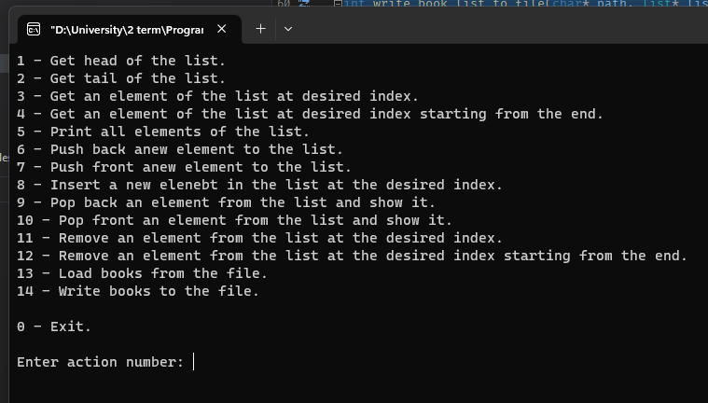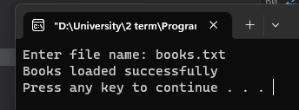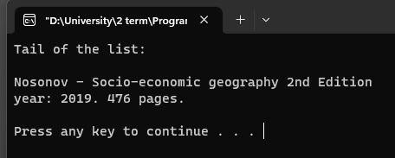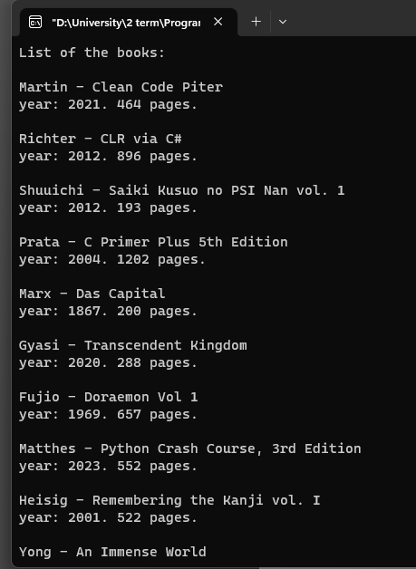

**Содержимое файлов**

books.txt – исходный файл, из которого считываются книги.

